Simulation of the line tracing of the robot controlled by the AI

2023/11/20 18:30:02

Table of Contents

1.Purpose 2

2.Simulation method 3

2.1. 3-D Simulation environment 3

2.2. Creating controller by transfer learning 3

3.Simulation result 5

3.1. Simulation condition 5

3.2. Trajectory 5

1.Purpose

In this report, we describe the simulation result of the line tracing using a network created by transfer learning as a controller. The aim of the simulation is investigating the possibility of future commercialization of the robot.

2.Simulation method

2.1. 3-D Simulation environment

In this simulation, line tracing was conducted using the following virtual course.



2.2. Creating controller by transfer learning

In this simulation, we have created a regression network to estimate the direction of the robot's movement by transfer learning using ResNet-18. The created network showed the following prediction results. Here, the green line represents the given teacher data, and the red line represents the predicted data by the network.

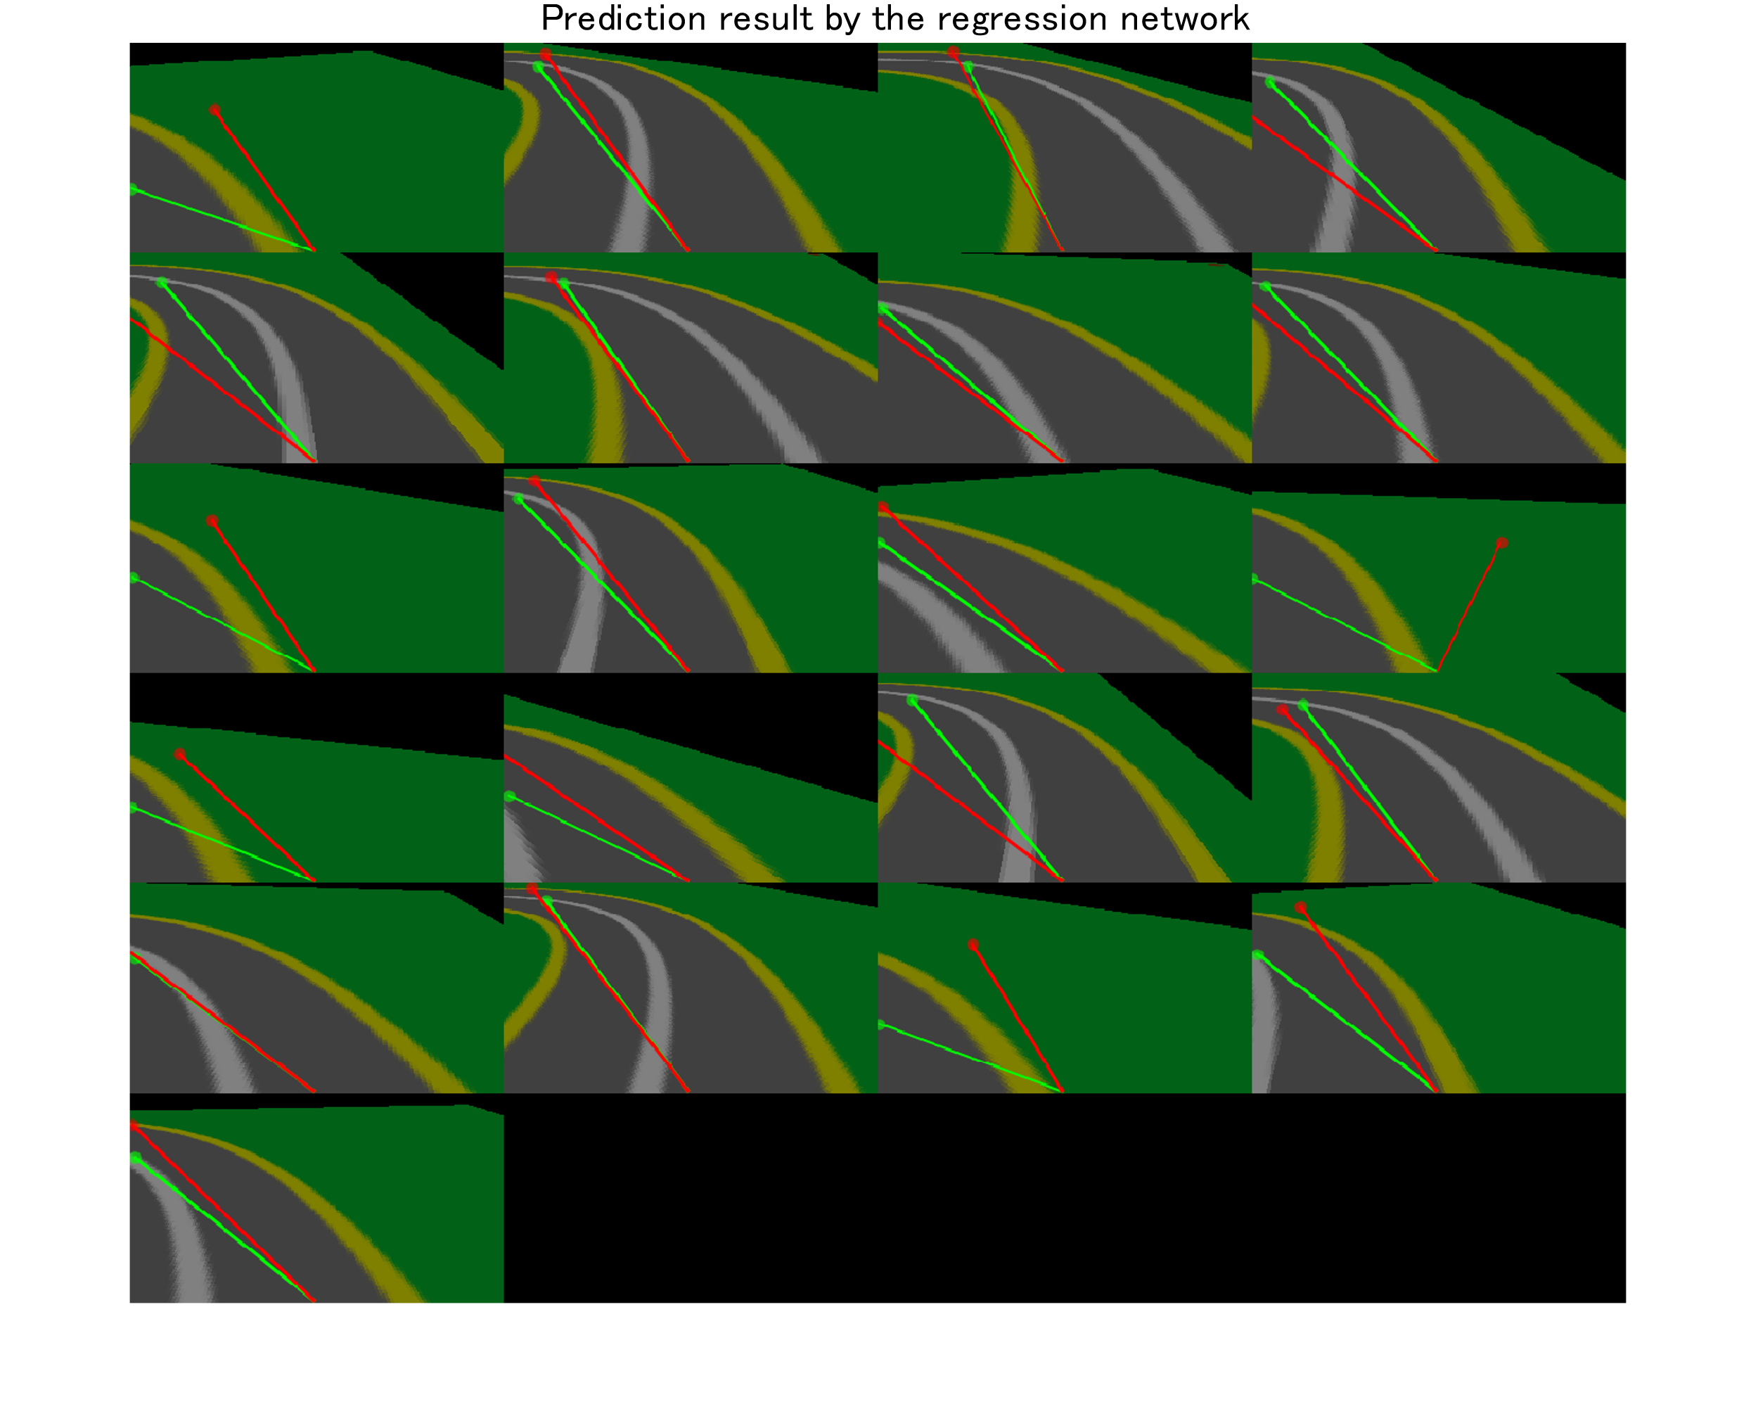

3.Simulation result

3.1. Simulation condition

The simulation was performed under the following conditions

|  |  |
| --- | --- |
| MATLAB version | R2021a |
| Simulation Time [s] | 20 |

3.2. Trajectory

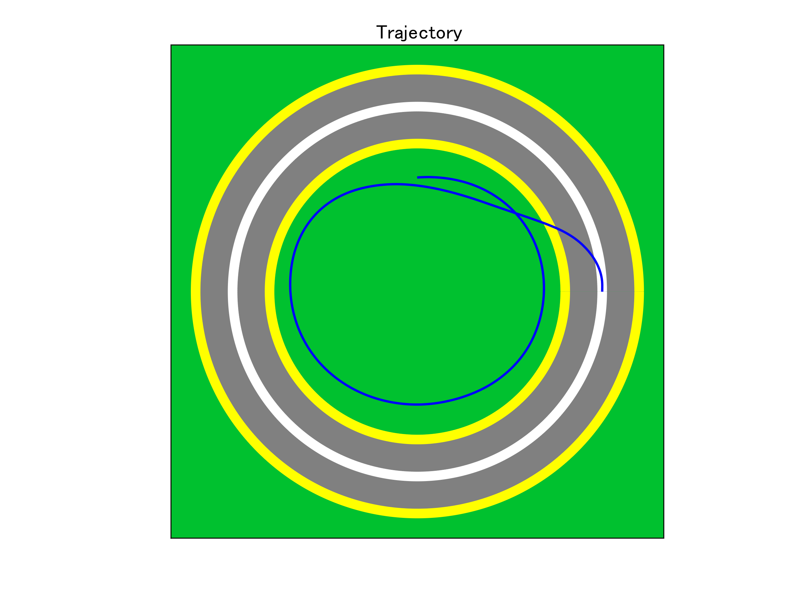

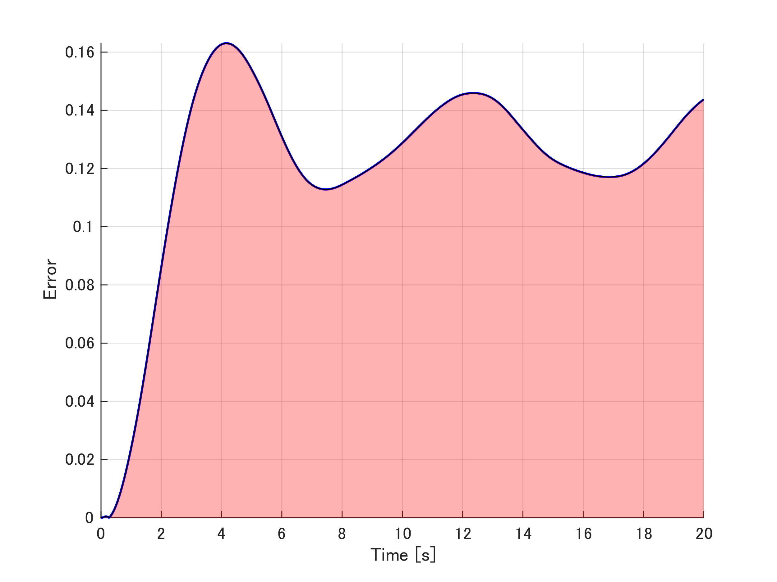

|  |  |
| --- | --- |
| Mean error | 0.121 |
| Max error | 0.16305 |